

Submitted by : Spogmai Jan

Roll no : 2430 -0081

Submitted to : Sir bilal dar

Subject : digital logic design lab

Assignment no 06

**Task#01:**

**Experimental result for Half Adder:**

**Table:**

|  |  |  |  |
| --- | --- | --- | --- |
| **A** | **B** | **Sum** | **Carry** |
| **0** | **0** | **0** | **0** |
| **0** | **1** | **1** | **0** |
| **1** | **0** | **1** | **0** |
| **1** | **1** | **0** | **1** |

**Switch 0 and Switch 1 is off Led 0 and Led 1 is off**

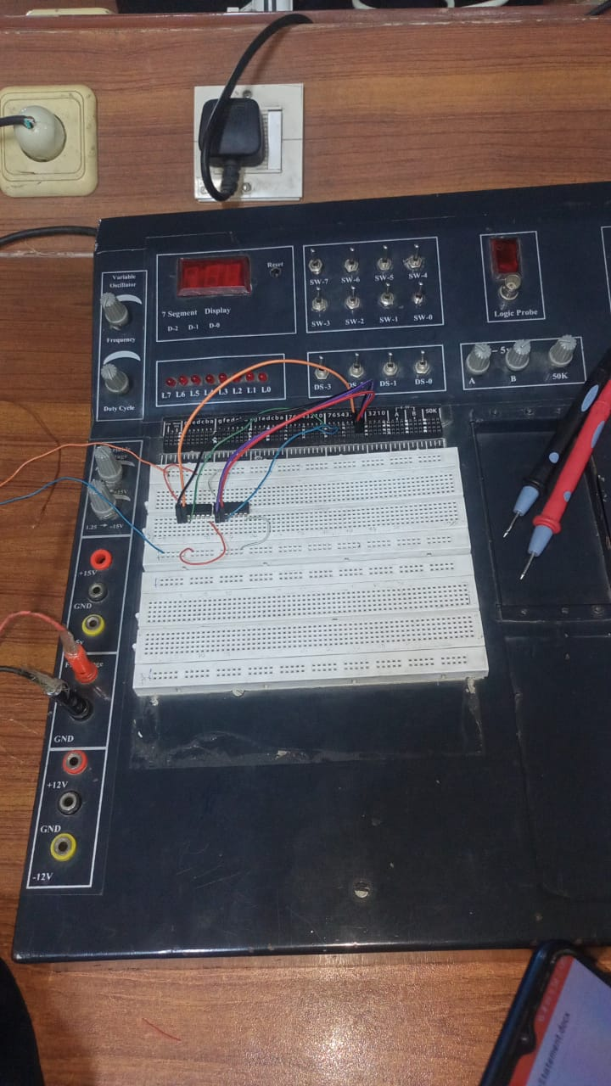

------------------------------------

Switch 0 is off Switch 1 is on Led 1 is on Led 0 is off

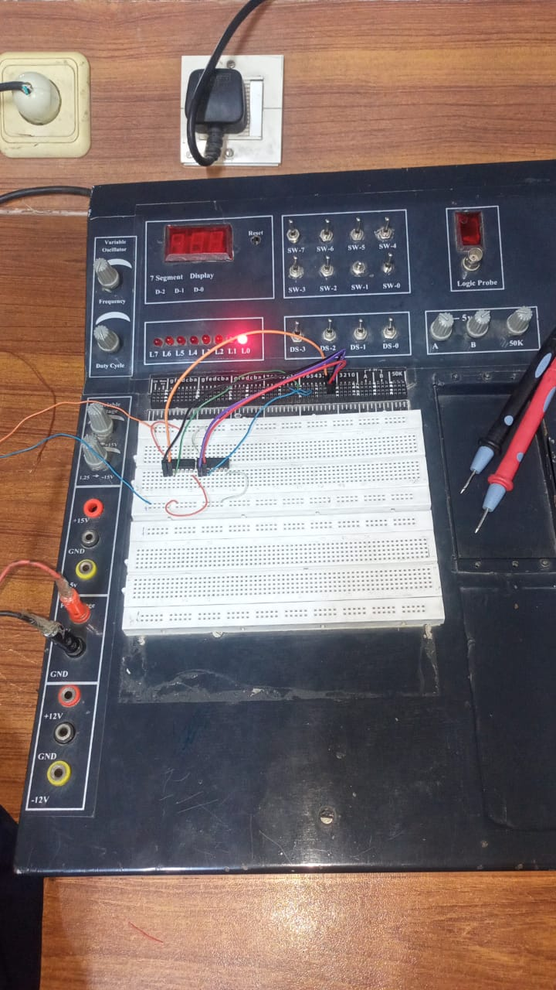

-----------------------------------------

Switch 0 is on Switch 1 is off Led 0 is on Led 1 is off

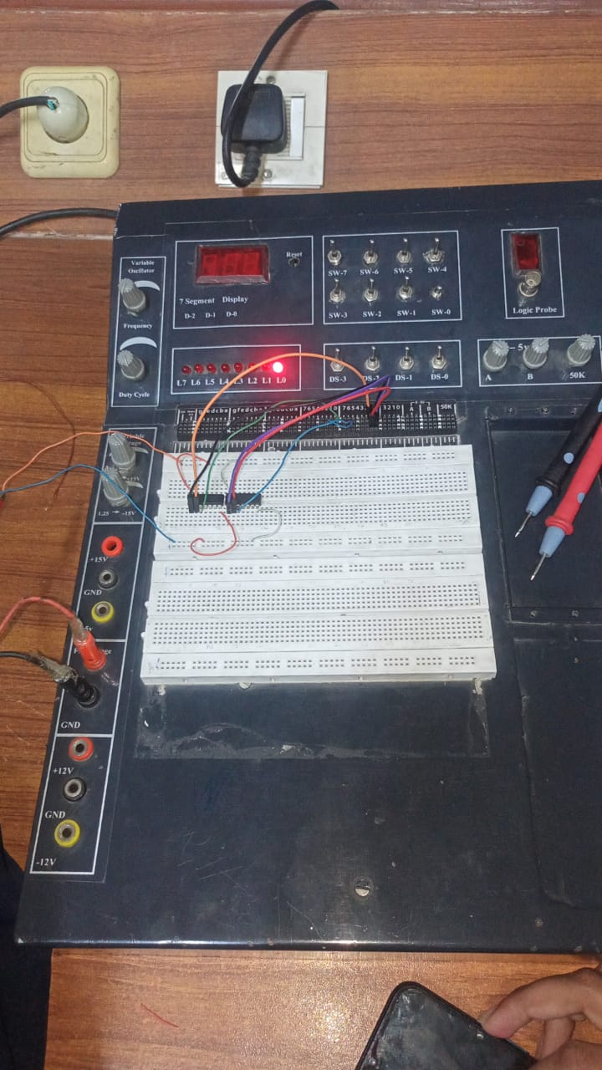

---------------------------------------------------------------

**Task#2:**

**Full Adder Circuit**

**Table:**

|  |  |  |  |  |  |
| --- | --- | --- | --- | --- | --- |
| **X** | **Y** | | **Z** | **Sum** | **Carry** |
| **0** | **0** | | **0** | **0** | **0** |
| **0** | **0** | | **1** | **1** | **0** |
| **0** | **1** | | **0** | **1** | **0** |
| **0** | **1** | | **1** | **0** | **1** |
| **1** | **0** | | **0** | **1** | **0** |
| **1** | **0** | | **1** | **0** | **1** |
| **1** | **1** | | **0** | **0** | **1** |
| **1** | | **1** | **1** | **1** | **1** |

**All switch is off then All Led is off**

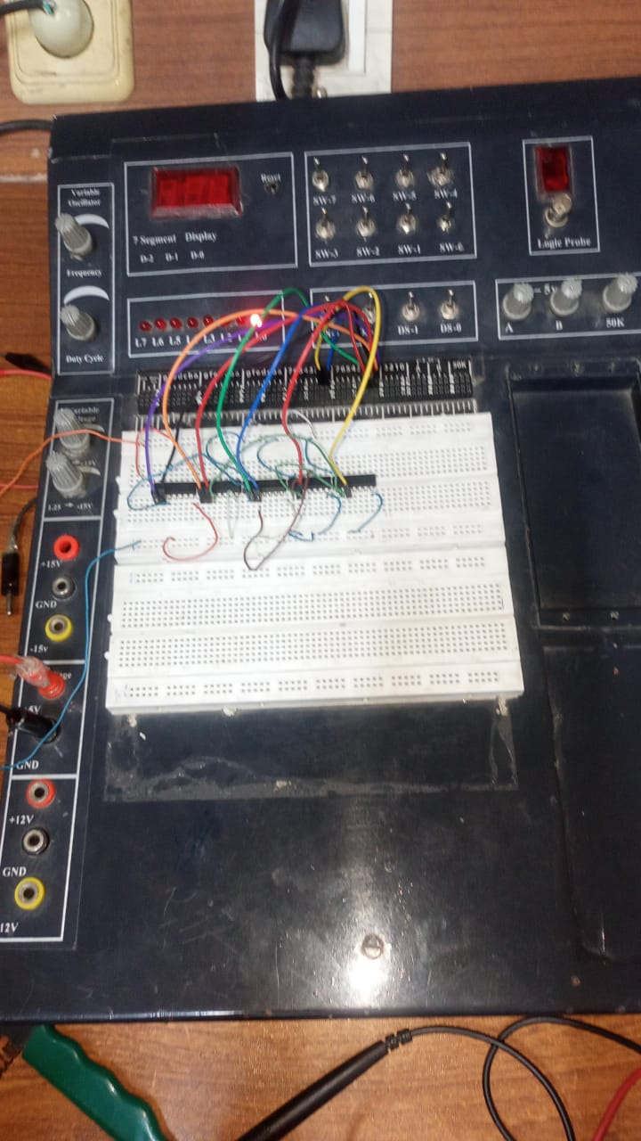

**All switches is on All Led is on**



